Parameters for Stripping REEs from Loaded Media
The purpose of this work was to optimize in situ acid stripping of REEs from loaded media in a column format. Several conditions were investigated and are reported here.
During experimental runs we tracked the pH of the effluent and REE concentration. We noticed that as the pH dropped below pH 2 the REEs began to elute or be stripped.
Beginning at room temperature (22ºC) column sorption load/strip studies were completed. Three initial acid strengths were explored, 0.067 M, 0.35 M and 1.0 M HNO₃. REEs measured in the effluent confirmed that we had excess volume of acid at all molarities which also negatively impacted subsequent media regeneration steps. The final procedure used to explore process details was reduced which lead to the following representative experimental procedure.
A column with fresh degassed Media 1 -50+100 in test Brine 1CF was slurry loaded into the test column following our standard protocol. The media used was preloaded with REE in a batch fashion. This was done to reduce our cycle time for a series of related experiments all designed to explore REE stripping from equivalently REE loaded media.
After loading, the column was equilibrated with brine simulant and the pH of the effluent monitored. No REEs were eluted and the pH was stable. The loaded media was stripped in situ by pumping a 30 ml bolus of HNO₃ at the designated acid strength through the column followed immediately by standard brine at the initial pH. As it turned out insignificant amounts of the REEs on the media were stripped using the 0.067 and 0.35 M HNO₃. Only the 1M HNO₃ produced complete stripping of the REEs as seen in the following graph.
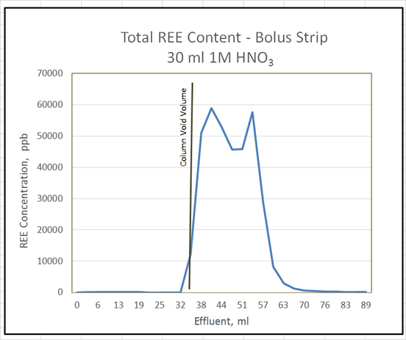

The column exhibited plug flow characteristics with the initial REE elution occurring at approximately one column void volume after acid introduction. The maximum elution concentration provided a bi-modal appearance suggesting that the REE stripping process was complex. Detailed analysis of the individual REEs eluted in two overlapping fractions. Lanthanum was the most abundant early eluting element while Neodymium was the most abundant late eluting element. Overall, greater than 90% of available REEs were removed.
Results from this work suggested that there was opportunity to further increase acid strength to more quickly elute the stripped REEs and reduce the bolus volume and/or increase the flow rate shortening the contact time.
The in situ stripping process was optimized for test conditions up to 90ºC to simulate a commercial process. Under optimized conditions the REEs were stripped simultaneously resulting in quantitative recovery represented graphically as a traditional Gaussian distribution as measured by total REE elution. Flow rate was also investigated to test the importance of contact time between the strip acid and the media. Under the experimental conditions a contact time of greater than 1 minute produced equivalent results.
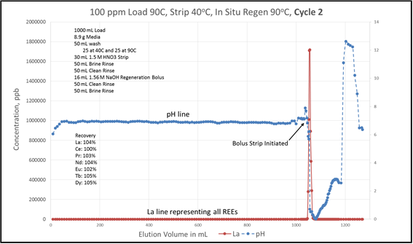
A graphical representation of an optimized load/strip cycle is seen the following graph as well as the specific experimental conditions. At the same time, the REE assay of the effluent represented by Lanthanum (La) and the pH of the effluent are tracked. The REE elution and the correlation to effluent pH is apparent.

